<datatable-demos></datatable-demos>

<div class="content-section">
<div>
<span class="feature-title">DataTable - <span class="subitem">Filter</span></span>
<span>Filtering is enabled by setting the filter property as true in column object. Default match mode is "startsWith" and this can be configured
using filterMatchMode property of column object that also accepts "contains", "endsWith", "equals" and "in". An optional global filter feature is available to search all fields with a keyword.
By default input fields are generated as filter elements and using templating any component can be used as a filter.
</span>
</div>
</div>

<div class="content-section implementation">
<div class="ui-widget-header" style="padding:4px 10px;border-bottom: 0 none">
<i class="fa fa-search" style="margin:4px 4px 0 0"></i>
<input #gb type="text" pInputText size="50" placeholder="Global Filter">
</div>
<p-dataTable [value]="cars" [rows]="10" [paginator]="true" [globalFilter]="gb" #dt>
<p-header>List of Cars</p-header>
<p-column field="vin" header="Vin (startsWith)" [filter]="true" filterPlaceholder="Search"></p-column>
<p-column field="year" header="Year ({{yearFilter||'No Filter'}})" [filter]="true" filterMatchMode="equals">
<ng-template pTemplate="filter" let-col>
<i class="fa fa-close" (click)="yearFilter=null;dt.filter(null,col.field,col.filterMatchMode)"></i>
<p-slider [style]="{'width':'100%','margin-top':'8px'}" [(ngModel)]="yearFilter" [min]="1970" [max]="2010" (onSlideEnd)="dt.filter($event.value,col.field,col.filterMatchMode)"></p-slider>
</ng-template>
</p-column>
<p-column field="brand" header="Brand (Custom)" [filter]="true" [style]="{'overflow':'visible'}" filterMatchMode="equals">
<ng-template pTemplate="filter" let-col>
<p-dropdown [options]="brands" [style]="{'width':'100%'}" (onChange)="dt.filter($event.value,col.field,col.filterMatchMode)" styleClass="ui-column-filter"></p-dropdown>
</ng-template>
</p-column>
<p-column field="color" header="Color (Custom)" [filter]="true" filterMatchMode="in" [style]="{'overflow':'visible'}">
<ng-template pTemplate="filter" let-col>
<p-multiSelect [options]="colors" defaultLabel="All Colors" (onChange)="dt.filter($event.value,col.field,col.filterMatchMode)" styleClass="ui-column-filter"></p-multiSelect>
</ng-template>
</p-column>
</p-dataTable>
</div>

<div class="content-section source">
<p-tabView effect="fade">
<p-tabPanel header="datatablefilterdemo.ts">
<pre>
<code class="language-typescript" pCode>
export class DataTableFilterDemo implements OnInit &#123;

cars: Car[];

brands: SelectItem[];

colors: SelectItem[];

constructor(private carService: CarService) &#123;&#125;

ngOnInit() &#123;
this.carService.getCarsMedium().then(cars => this.cars = cars);

this.brands = [];
this.brands.push(&#123;label: 'All Brands', value: null&#125;);
this.brands.push(&#123;label: 'Audi', value: 'Audi'&#125;);
this.brands.push(&#123;label: 'BMW', value: 'BMW'&#125;);
this.brands.push(&#123;label: 'Fiat', value: 'Fiat'&#125;);
this.brands.push(&#123;label: 'Honda', value: 'Honda'&#125;);
this.brands.push(&#123;label: 'Jaguar', value: 'Jaguar'&#125;);
this.brands.push(&#123;label: 'Mercedes', value: 'Mercedes'&#125;);
this.brands.push(&#123;label: 'Renault', value: 'Renault'&#125;);
this.brands.push(&#123;label: 'VW', value: 'VW'&#125;);
this.brands.push(&#123;label: 'Volvo', value: 'Volvo'&#125;);

this.colors = [];
this.colors.push(&#123;label: 'White', value: 'White'&#125;);
this.colors.push(&#123;label: 'Green', value: 'Green'&#125;);
this.colors.push(&#123;label: 'Silver', value: 'Silver'&#125;);
this.colors.push(&#123;label: 'Black', value: 'Black'&#125;);
this.colors.push(&#123;label: 'Red', value: 'Red'&#125;);
this.colors.push(&#123;label: 'Maroon', value: 'Maroon'&#125;);
this.colors.push(&#123;label: 'Brown', value: 'Brown'&#125;);
this.colors.push(&#123;label: 'Orange', value: 'Orange'&#125;);
this.colors.push(&#123;label: 'Blue', value: 'Blue'&#125;);
&#125;
&#125;
</code>
</pre>
</p-tabPanel>

<p-tabPanel header="datatablefilterdemo.html">
<pre>
<code class="language-markup" pCode ngNonBindable>
&lt;div class="ui-widget-header" style="padding:4px 10px;border-bottom: 0 none"&gt;
&lt;i class="fa fa-search" style="margin:4px 4px 0 0"&gt;&lt;/i&gt;
&lt;input #gb type="text" pInputText size="50" placeholder="Global Filter"&gt;
&lt;/div&gt;
&lt;p-dataTable [value]="cars" [rows]="10" [paginator]="true" [globalFilter]="gb" #dt&gt;
&lt;p-header&gt;List of Cars&lt;/p-header&gt;
&lt;p-column field="vin" header="Vin (startsWith)" [filter]="true" filterPlaceholder="Search"&gt;&lt;/p-column&gt;
&lt;p-column field="year" header="Year (&#123;&#123;yearFilter||'No Filter'&#125;&#125;" [filter]="true" filterMatchMode="equals"&gt;
&lt;ng-template pTemplate="filter" let-col&gt;
&lt;i class="fa fa-close" (click)="yearFilter=null;dt.filter(null,col.field,col.filterMatchMode)"&gt;&lt;/i&gt;
&lt;p-slider [style]="&#123;'width':'100%','margin-top':'8px'&#125;" [(ngModel)]="yearFilter" [min]="1970" [max]="2010" (onSlideEnd)="dt.filter($event.value,col.field,col.filterMatchMode)"&gt;&lt;/p-slider&gt;
&lt;/ng-template&gt;
&lt;/p-column&gt;
&lt;p-column field="brand" header="Brand (Custom)" [filter]="true" [style]="&#123;'overflow':'visible'&#125;" filterMatchMode="equals"&gt;
&lt;ng-template pTemplate="filter" let-col&gt;
&lt;p-dropdown [options]="brands" [style]="&#123;'width':'100%'&#125;" (onChange)="dt.filter($event.value,col.field,col.filterMatchMode)" styleClass="ui-column-filter"&gt;&lt;/p-dropdown&gt;
&lt;/ng-template&gt;
&lt;/p-column&gt;
&lt;p-column field="color" header="Color (Custom)" [filter]="true" filterMatchMode="in" [style]="&#123;'overflow':'visible'&#125;"&gt;
&lt;ng-template pTemplate="filter" let-col&gt;
&lt;p-multiSelect [options]="colors" defaultLabel="All Colors" (onChange)="dt.filter($event.value,col.field,col.filterMatchMode)" styleClass="ui-column-filter"&gt;&lt;/p-multiSelect&gt;
&lt;/ng-template&gt;
&lt;/p-column&gt;
&lt;/p-dataTable&gt;
</code>
</pre>
</p-tabPanel>
</p-tabView>
</div>

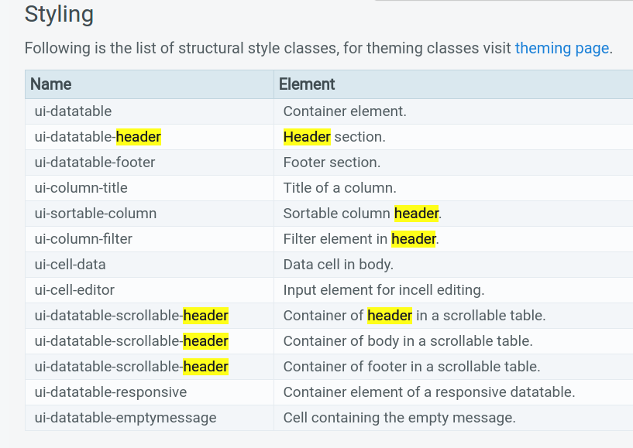

word-wrap:break-word;

Each p-column can have two templates - body and header, you should specify which one it is. It's not mandatory because body is default I think and this is what you need in this case, but it's good practice. You also need to add pTemplate to template in order for p-column to use it, this is the reason p-column won't display template you provided. So, your code should look like this:
<p-dataTable [hidden]="loading" [value]="files" selectionMode="single" sortField="Status" [sortOrder]="-1">
<p-column field="FileName" header="Naam" sortable="true"></p-column>
<p-column field="Status" header="Status" sortable="true">
<template let-file="rowData" pTemplate type="body">
{{file.Status == 1 ? "Yes" : "No"}}
</template>
</p-column>
</p-dataTable>

